

**Introduction to Database System**

**Spring 2022**

# **Final Term Lab**

# **VERSION II**

**Time Allowed: 90 min**

|  |  |
| --- | --- |
| Name: |  |
| Registration No |  |
| Serial Number (of attendance sheet) |  |

|  |  |  |  |
| --- | --- | --- | --- |
|  | DDL | DML | Total |
| Total Marks | 15 | 35 | 50 |
| Ob. Marks |  |  |  |

**Instructions:**

1. **This is a closed book, closed notes paper.**
2. **Understanding questions is part of the paper**. Therefore, no queries will be entertained during examination.
3. chess.sql file is uploaded on teams/portal. Use those files to attempt the DML section of paper.
4. Use proper indentation/formatting while writing queries. Not properly indenting will deduct 5% marks.
5. **You need to make an MS Word with your name and registration should be mentioned on each page.**
6. **You need to write only queries with output in MS Word file, you need to write query (text form) + its output table (picture) if any.**
7. **You will solve the DDL + DML section only in word docx.**

# **Part 1 DDL** **[15 Marks]**

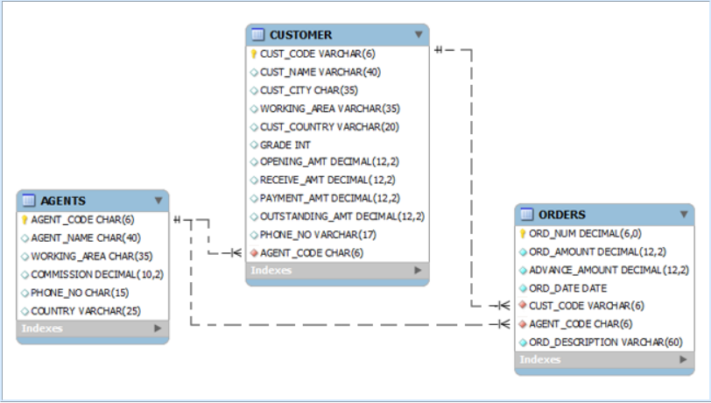

**Q1.** Implement the table customer table with its attributes. Make primary keys and foreign keys if any. **[5 Marks]**

**Q2.** Make the required modifications **[10 Marks]**

1. Add a column in email in customer table.
2. Add constraint foreign key from agents to customer and customer to orders table.
3. Change the data type of commission in agents table from decimal to double.
4. Set default value of grade in Customer table to 001.

# **Part 2 DML** **[35 Marks]**

* **Import chess.sql schema.**

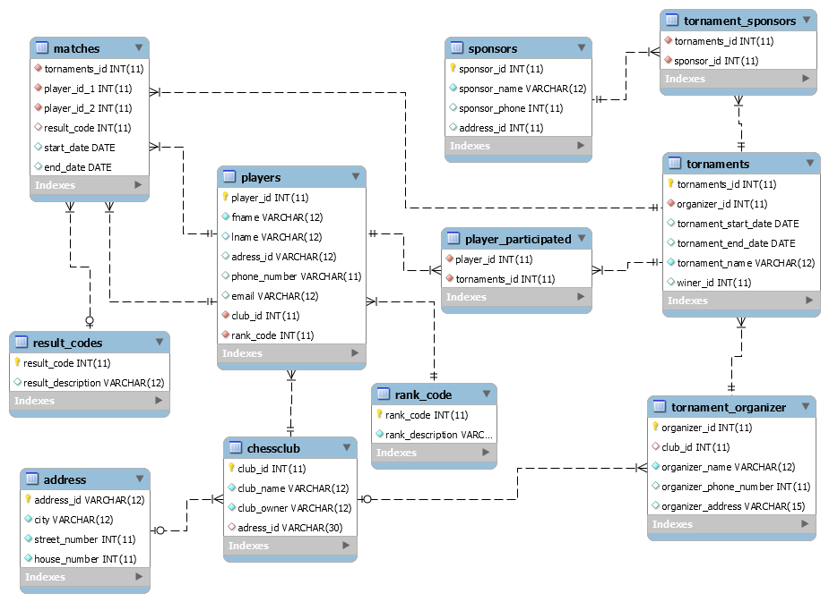

**Solve the following questions from the above schema: (5+6+6+6+12)**

**Q#1:**

Display name of those players who played in the recent tournament**. [Don’t use cross product]**

**Q#2:**

Create a view as your name that displays every sponsor name with total count of tournaments sponsored by him in descending order. **[use correlated query]**.

**Q#3:**

Print the count of the player who participated in the tournament name ‘grand master’. **[use nested query]**

**Q#4:**

Print the name of sponsors who have sponsored not more than one tournament**. [Don’t use cross product]**

**Q#5** :

Create a view of ‘Players’ named as participants and by using this table in a stored procedure named tournament_players, display first name of all those players that participated in tournament whose end date is in year 2004 and then returns the result in the output variable by using multiple parameters**.[View and Stored Procedure]**